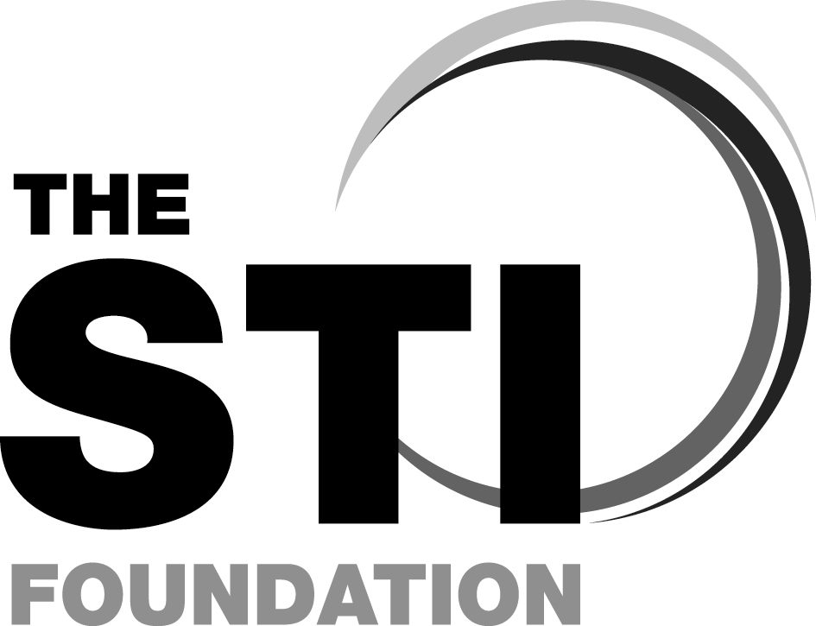

Sexually Transmitted Infections Foundation Course

STIF CORE

STIF PLUS

Courses from the British Association for Sexual Health and HIV (BASHH)

STIF CORE:

22nd Nov 2019

STIF PLUS: 23rd Nov 2019

at

Gledhow wing seminar rooms, St James University Hospital, Leeds

COURSE DIRECTOR: Dr Harriet Wallace

COURSE ORGANISER:
Leeds Sexual Health
Contact Roz Armitage via lshadmin.lch@nhs.net

(on behalf of BASHH)

The aim of the course is to equip participants with the basic knowledge, skills and attitudes for the effective management of sexually transmitted infections (STIs) outside the GUM setting.
Early registration is preferable. It is recommended to attend both days although if you have attended a STIF course in the past 3 years, you can attend the STIF PLUS day to update your knowledge and skills.
It is highly recommended that delegates study the appropriate modules in e-Learning for Health before attending.
This will entail around 8-12 hours of study depending on your experience.
The outline programme is overleaf.
For further information please visit http://www.stif.org.uk

This is a multi-disciplinary course and applications are invited from: Doctors and nurses working in general practice, family planning and reproductive health, GUM, health advisers, secondary care clinicians who may encounter patients with STIs (e.g. O&G, A&E, rheumatology, ophthalmology), pharmacists, school nurses.
Course fee (includes Coffee breaks & lunch)
STIF CORE £150,
STIF-PLUS £150
BOTH DAYS £250
To reserve a place, please register via:
https://www.eventbrite.com/e/sexually-transmitted-infections-foundation-course-tickets-66464700709
Your registration will not be processed until you return the following form, with a cheque made payable to “Leeds Community Healthcare Trust”

ALL APPLICATIONS SHOULD BE
RETURNED BY 1st Nov 2019 (contact organiser if wishing to register after this date)
Receipt and course materials will be emailed to you
FSRH Approved

Sexually Transmitted Infections Foundation Course
22nd/23rd Nov 2019, SJUH, Leeds
REGISTRATION FORM

NAME
Present Post
NHS Workplace/ Institution
Postal Address
Daytime contact tel
Email address for joining instructions, course pack & receipt
Please specify any special needs
Please indicate the days which you wish to attend:
DAY ONE (STIF CORE)
DAY TWO (STIF PLUS – assumes attendance on a STIF Course in last 3 years)
BOTH DAYS
I wish an invoice to be raised for my registration fee - please state to whom the invoice is to be addressed. Applications will not be processed until this is confirmed. Invoices must be paid in advance of sending any course materials:

Please return completed application & cheque payable to “Leeds Community Healthcare NHS Trust” to
Roz Armitage, Leeds Sexual Health Administration, Wade House, 50 Merrion Way, Leeds, Ls2 8NG
Tel: 0113 3920318 E-mail: lshadmin.lch@nhs.net

RevJune 18

Aim of STIF FOUNDATION course
To equip participants with the basic knowledge, skills and attitudes for the effective management of STIs. By the end of the course you should be able to:

Knowledge
- describe the principles of STI service provision
- recognise the issues relating to confidentiality, partner notification and treatment
- demonstrate basic knowledge of the epidemiology and the factors involved in the transmission of STIs and how to prevent transmission
- demonstrate basic knowledge of STIs, their presentation, diagnosis and management
- indicate where and when to refer patients

Skills
- demonstrate competency, and feel comfortable, in taking a sexual history
- demonstrate the skills necessary to inform patients about reducing their risk of sexual infections and risk of unplanned pregnancy
- optimise care pathways for patients through improved links with local services (GUM, Sexual Health, Contraceptive services, Psychosexual services, Microbiology, TOP services and Primary Care)

Attitudes
- demonstrate an appreciation of the lifestyle and circumstances of others and how this may reflect in their presentation and impact on their management.
- recognise the range of human sexuality, lifestyles and culture and the impact this has on transmission/ prevention counselling
- demonstrate an understanding of how one’s personal beliefs could affect the consultation

Day 1 (STIF CORE ):
Programme timings may change

08.45 Registration
09:00 Welcome, introduction – what we do
09:10 Session – Sexual History, Recognition of Symptoms & Risk Assessment
09.50 Session – Routine diagnostic tests and examination
Coffee
10.50 Session – Partner Notification; why it matters and how to signpost
11.35 Session – HIV Testing
Lunch
14.00 Small Group Workshops

- Sexual Health Promotion, Risk Reduction & Prevention
- Genital sores
- Vaginal discharge
- Young People and Sexual Health

Day 2 (STIF PLUS):
Programme timings may change

09:00 Registration
09:00 Welcome
09:15 Session - Clinical HIV
10.15 Session- Domestic Abuse and Sexual Assault
Coffee
11.15 Session - Viral Hepatitis - an overview
12.00 Small Group Workshops x 2
Lunch
14.00 Small Group Workshops x 2
Tea
15.45 Session – STIs in Pregnancy
16:30 Session - Syphilis
17.15 Meeting with mentors
17.30 Close

SMALL GROUP WORKSHOPS
- Male Dysuria, Testicular Pain and Testicular Lumps
- Conditions affecting genital skin
- Pelvic Pain
- Gay, bisexual,transgender and other MSM

STIFCOMPETENCY PROGRAMME
Having attended the STIF Foundation course, you may be interested in registering for STIF Competency workplace training and assessment which provides a nationally recognised training and assessment qualification in sexual health. It is a modular competency-based work place based training and assessment package for non-specialist and specialist healthcare professionals requiring skills development to manage people with sexually transmitted infections. Trainees successfully completing the competencies are registered on the national STIFCompetency database of accredited healthcare professionals. www.stif.org.uk

