[](http://www.google.com/url?sa=i&rct=j&q=&esrc=s&source=images&cd=&cad=rja&uact=8&ved=2ahUKEwio-5Omr7faAhVTsBQKHWT_BEsQjRx6BAgAEAU&url=http://www.nursetheory.com/best-stethoscopes/&psig=AOvVaw2b56NQONOXTEp7aJipmKQL&ust=1523712965488426)

MINOR SURGERY SKILLS COURSE

For: GENERAL PRACTITIONERS

GP TRAINEES/NURSE PRACTITIONERS

Clinical specialists from our teaching hospitals deliver

courses for GP`s, nurse practitioners and GP trainees

who need a comprehensive update on how to manage common conditions or training for their continuing professional development.

**DATE: 18 November 2019**

**Venue: Newcastle Surgical Training Centre**

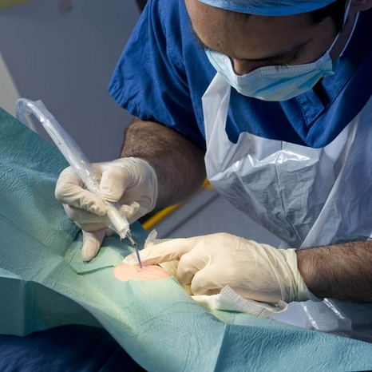

**Newcastle Surgical Training Centre delivers over 170 advanced training courses from regional, national and international surgeons representing multi specialties. Collaboration with national and international faculty drives a greater understanding of surgical techniques delivering improved patient care.**

**www.nstcsurg.org**

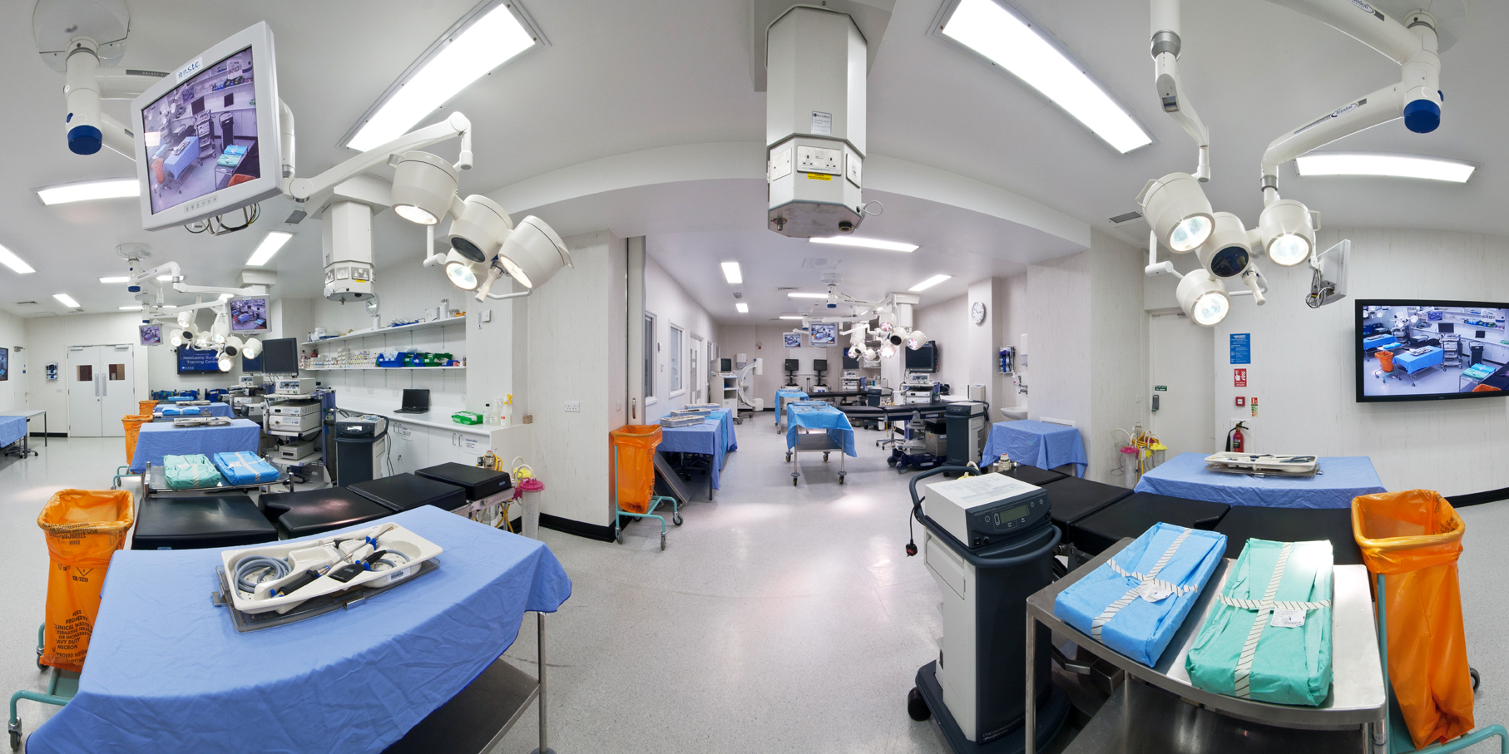

COURSE INCLUDES

* **Anatomy and physiology of wound healing**
* **Skin Pathophysiology**
* **Essential Skin Surgery**
* **Common skin lesions, sebaceous cysts and lipomas**
* **Cryotherapy/Local Anaesthesia**
* **Peri/Postoperative Wound Care**
* **Curretage, cautery and diathermy**
* **Ingrown Toenail**

**Joint Injections**

Symptoms and Signs of Joint Injections

* Differential diagnosis
* Indications/Contra Indications
* Aseptic Technique
* Aftercare

**Practical Workshops on Porcine Tissue**

* **Local anaesthetic technique**
* **Suturing technique**
* **Removal of sebaceous cysts**
* **Removal of lipomas**
* **Wound Dressings**

**Aims & Objectives**

* **How to close wounds effectively**
* **How to use simple dressings**
* **When to do minor skin surgery**
* **Basics of skin flaps**

COURSE OVERVIEW

This course is a One day hands on practical cadaveric workshop for General Practitioners, GP Trainees and Practice Nurses and is designed to build confidence and consolidate the skills of clinical specialists who regularly perform minor surgery

**The programme consists of intensive technical tuition in minor surgery techniques delivered in small group informal theory and hands on practical sessions under the supervision of some of the most experienced clinicians in the field**

* **An intensive course**
* **Number of attendees limited to 12**
* **Refreshments included**
* **Course certificate on completion**
* **The course uses Porcine Tissue**



For further details please contact:

Louise Sore,

Newcastle Surgical Training Centre

Freeman Hospital

Newcastle upon Tyne

NE7 7DN

Email: [louise.sore @nuth.nhs.uk](mailto:gail.russell@nuth.nhs.uk)

Tel: 0191 213 8589

Website: [**www.nstcsurg.org**](http://www.nstcsurg.org/)

**FACULTY**

Dan Saleh, Consultant Plastic Surgeon

David Sainsbury, Consultant Plastic Surgeon

Thomas Oliphant, Consultant Plastic Surgeon

Tracy Leck, Nurse Specialist

Mr Mogdad Alrawi, Consultant Plastic Surgeon

Mr David Brass, Consultant Dermatologist

Sahan Rannan-Eliya -Consultant Plastic Surgeon

Simon Chambers, Consultant Ortho Surgeon

Sioban Muthiah, Consultant

Steve Borland, Consutlant Ortho Surgeon

**www.nstcsurg.org**

**Newcastle Surgical Training Centre**

Application Form

Course title:

MINOR SURGERY SKILLS COURSE FOR GENERAL PRACTITIONERS

Date: 18 November 2019

COURSE FEE: £275.00

|  |  |
| --- | --- |
| Your details | |
| Surname: | Title: (Mr / Mrs / Miss / Ms ) |
| Forenames: | |
| GP PRACTICE |  |
| PRACTICE ADDRESS: | Postcode: |
|  |  |
| Mobile Telephone Number: | Email: |

|  |
| --- |
| Further details |
| How did you hear about this course? Trust Website Mailing Other |
|  |
| Please state any special dietary requirements: |
|  |
|  |
|  |
| Please state to whom invoices should be addressed, if no alternative contact is given, all invoices  will be directed to the applicant |

|  |  |
| --- | --- |
| Declaration | |
| Signed: | Date: |

     

     

     

     

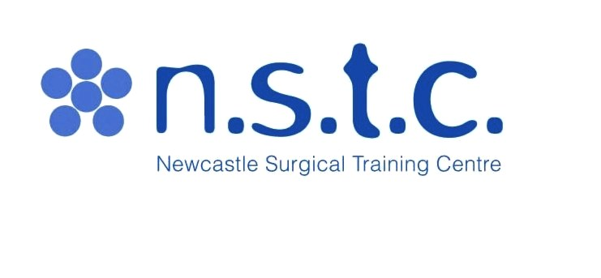 **Newcastle Surgical Training Centre**

**On line Credit Card Payment Authorization Form**

Sign and complete this form to authorize **Newcastle Surgical Training Centre** to make a one time debit to your credit card listed below. By signing this form you give us permission to debit your account for the amount indicated on or after the indicated date. This is permission for a single transaction only, and does not provide authorization for any additional unrelated debits or credits to your account.

**Please complete the information below:**

Please state Name: I ……………………………………………………………………… authorize Newcastle Surgical Training Centre to charge my credit card   
  
£275 – GP Minor Skills Course – 18 November 2019

**Address including Postcode:**

|  |  |
| --- | --- |
|  |  |
|  |  |
|  |  |
|  |  |
|  |  |
|  |  |

|  |  |
| --- | --- |
| **Email:** |  |
| **Phone:** |  |

|  |  |  |  |  |  |  |  |  |  |  |
| --- | --- | --- | --- | --- | --- | --- | --- | --- | --- | --- |
| Account Type:  Visa  MasterCard  Discover **WE DO NOT ACCEPT DINERS CLUB OR AMEX**   |  |  | | --- | --- | | **Cardholder Name** |  | | **CARD Number** | ______________________________________________________________________ | | **Expiration Date** | _____________________________________________________________________ | | **Valid from date**  **Security number(3 digit number on back of Visa/MasterCard** | ____________________________________________________________________  ­­­­­­­­­­­­­­­­­­­_____________________________________________________________________  ­­­­­­­­­­­­­­­­­­­­­­­­­­­­­­­ | |  |  | |

**SIGNATURE:** **DATE:**

I authorize the above named business to charge the credit card indicated in this authorization form according to the terms outlined above. This payment authorization is for the goods/services described above, for the amount indicated above only, and is valid for one time use only. I certify that I am an authorized user of this credit card and that I will not dispute the payment with my credit card company; so long as the transaction corresponds to the terms indicated in this form.

**Newcastle Surgical Training Centre, Freeman Hospital, High Heaton, Newcastle upon Tyne. NE7 7DN**

**Tel 0191 24 48913 Email: Lorraine.waugh@nuth.nhs.uk**

|  |  |  |  |  |  |  |  |  |  |
| --- | --- | --- | --- | --- | --- | --- | --- | --- | --- |
| COURSE PAYMENT OPTIONS | | | | | |  | | | |
| **Newcastle Surgical Training Centre**  **Freeman Hospital**  **High Heaton**  **Newcastle upon Tyne NE7 7DN**  **TEL: 0191 24 48913** | | | | | | | | | |
| Payment Options |  |  | | |  | |  | |  |
|  | | | | | | | | | |
| **If you wish to make a payment by cheque:** | | | | | | | | | |
| Please make the cheque payable to: Newcastle upon Tyne Hospitals NHS Trust | | | | | | | | | |
|  | | | | | | | | | |
| **If you wish to make a payment by credit card:** | | | | | | | | | |
| Please contact Freeman Hospital, Cashiers Department | | | | Telephone Number | | | | 0191 21 37694 | |
| Please quote: NSTC/XOT245/60130 | | | |  | | | |  | |
| Please state the Name of the Course | | | |  | | | |  | |
| |  |  |  |  | | --- | --- | --- | --- | | **If you wish to pay by BACS** | | | | | **Bank Name** | **HSBC** | | | | **Bank Address** | **110 Grey Street, Newcastle upon Tyne. NE1 6JG** | | | | **Sort Code** | **403418** | **Account No: 41763709** | **NUTHNo.1** | | **IBAN No:** | **GB86MIDL40341841763709** | | **Swift Code: MIDLGB2108J** | | **Ref:** | **SURGTRAINING** | |  | | **Newcastle upon Tyne Hospitals NHS Trust VAT NO:** | | | **654968777** | | | | | | | | |  | |
|  | | |  | | | | | | |



**Please note:** The course fee will include: lunch and refreshments. Payment can be made via BACS (automatic bank transfer)

by Credit Card, or by cheque payable to **Newcastle upon Tyne Hospitals NHS Trust.**

Full details and registration information at www.nstcsurg.org Please note payment is due at registration to secure your place. Attendance on the course is conditional upon advance payment being received. Refunds cannot be given in the event of your cancellation within two weeks of the course date. The NSTC cannot accept liability for costs incurred in the event of a course having to be cancelled as a result of circumstances beyond its reasonable control.