

**Greener General Practice Scheme**

**2021/22**

The Leeds LMC held a Climate Change event in December 2021 and identified an enthusiasm for responding to the health emergency that climate change brings.

This scheme has therefore been developed in collaboration with the Leeds Greener Practice Group to support practices in identifying actions and contributing to the ambitions of the wider NHS to reduce the overall NHS carbon footprint.

**Background and Context**

The NHS has set out a national ambition which is “*To deliver the world’s first net zero health service and response to climate change, improving health now and for future generations*”.

Two clear and feasible targets emerge for the NHS net zero commitment, based on

the scale of the challenge posed by climate change, current knowledge, and the

interventions and assumptions:

* for the emissions we control directly (the NHS Carbon Footprint), net zero by 2040, with an ambition to reach an 80% reduction by 2028 to 2032
* for the emissions we can influence (our NHS Carbon Footprint Plus), net zero by 2045, with an ambition to reach an 80% reduction by 2036 to 2039.[1]

In 2019, Leeds City Council passed a motion to declare a climate emergency with a resolution to make Leeds carbon neutral by 2030.

The link between health and climate change is well documented with air pollution linked to conditions like heart disease, stroke and lung cancer and therefore provides a real opportunity for us all to play a part in prevention through action to reduce our carbon footprint, articulated by the diagram below.

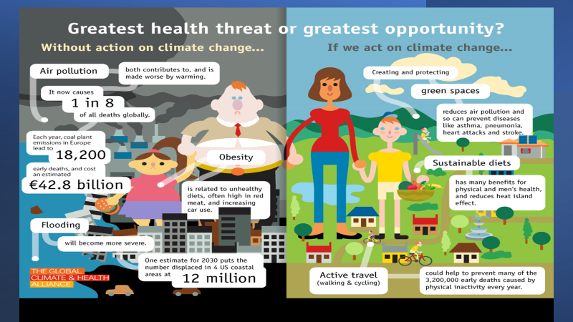

**Scheme Details**

For each practice that returns the commitment below, a payment of £1,000 will be paid to the practice to reflect the engagement of this work and any costs associated with making greener choices.

|  |  |
| --- | --- |
| ***Action*** | **Practice Response** |
| **Practice Name** | *We confirm that we will make a commitment to looking at sustainable choices and planetary health*  **Practice Name** |
| **Name & email of Practice Champion**  *To receive updates from the greener practice group* [*https://www.greenerpractice.co.uk/join-our-network/local-groups/leeds/*](https://www.greenerpractice.co.uk/join-our-network/local-groups/leeds/) | **Name:**  **Email address:** |
| Undertake the Green Impact for Health Tookit  <https://www.greenimpact.org.uk/giforhealth> | We confirm that the practice will undertake the toolkit and provide updates on any actions  Yes No |
| Please identify any other actions that the practice is undertaking to support a more sustainable and greener service |  |

Other opportunities the practice might wish to consider include:

|  |  |
| --- | --- |
| * LED lighting replacement * Track and report carbon footprint <https://www.gpcarbon.org/#/> * Encouraging staff and patients to reduce vehicle use * Plastic Reduction Pledge * Greener Practice Asthma Toolkit <https://www.greenerpractice.co.uk/greener-practice-guide-to-inhaler-prescribing> | * Switch to recycled content paper for all office based functions * Signpost to green prescribing initiatives (social activities involving time spent in nature such as gardening and guided walks) * Switch to renewable energy * Engage your PPG * Contribution to the IIF indicators on sustainability |
|  |  |

**Further information**

<https://www.greenerpractice.co.uk/join-our-network/local-groups/leeds/>

<https://www.england.nhs.uk/gp/case-studies/moving-towards-a-greener-general-practice/>

*Includes a case study on Colton Mill Medical Centre, Leeds*

<https://www.england.nhs.uk/gp/case-studies/general-practice-and-the-local-community-tackling-climate-change-together/>

[*https://www.rcgp.org.uk/policy/rcgp-policy-areas/climate-change-sustainable-development-and-health.aspx*](https://www.rcgp.org.uk/policy/rcgp-policy-areas/climate-change-sustainable-development-and-health.aspx)

[*https://seesustainability.co.uk/resources*](https://seesustainability.co.uk/resources)

Thank you for your commitment to supporting a greener NHS. If you have any further ideas to support this agenda please share as part of the greener practice group.

**Please your complete form to** [**leedsccg.primarycare@nhs.net**](mailto:leedsccg.primarycare@nhs.net)

1. Delivering a ‘Net Zero’ National Health Service