Focus on Registration of Overseas Visitors

Focus on Registration of Overseas Visitors

As part of the 2017/18 contract negotiations we have agreed with NHS Employers contractual changes that will help to identify patients with a non-UK issued EHIC (European Health Insurance Card) or S1 form or who may be subject to the NHS (Charges to Overseas Visitors) Regulations 2015.

This will allow the NHS to recover costs from the patient’s country of origin for any care provided which comes under the NHS (Charges to Overseas Visitors) Regulations 2015. This currently applies only to secondary care provision. Practices should note that this does not affect the entitlement of such patients to register with a GP.

What practices will need to do

From October practices are required to provide patients with a supplementary question form as part of the registration process. This is included as part of a revised GMS1, or can be provided separately if the practice uses its own registration forms. This will allow patients to self-declare if they hold either a non-UK issued EHIC or a S1 (formerly E106), and provide the relevant details. The practice will not be required to follow up with the patient if they do not fill in these details.

For patients that do provide these details practices will be required to record that the patient holds either a non-UK issued EHIC or a S1 form in the patient’s medical record and then send a copy of the GMS1 and supplementary questions to:

EHIC
NHS Digital at: NHSDigital-EHIC@nhs.net

S1 Form
The DWP Overseas Healthcare Team at: overseas.healthcare@dwp.gsi.gov.uk

Where a patient presents an S1 form practices should also send a copy of this to the DWP Overseas Healthcare Team at the same address to allow it to be registered.

All other aspects of the registration process remain unchanged and practices should have received copies of leaflets to provide to patients to explain the process.

Further guidance, including detail on NHS Digitals recommended processes, can be access via NHS Employers.

The Regulations:

Information relating to overseas visitors

- A contractor must—

- record the information specified in paragraph relating to overseas visitors, where that information has been provided to it by a newly registered patient on a form supplied to the contractor by the Board for this purpose; and

- where applicable in the case of a patient, record the fact that the patient is the holder of a European Health Insurance Card or S1 Healthcare Certificate(e) which has not been issued to or in respect of the patient by the United Kingdom, in the medical record that the contractor is required to keep under regulation 67 in respect of the patient.

(2) The information specified in this paragraph is—

(a) in the case of a patient who holds a European Health Insurance Card which has not been issued to the patient by the United Kingdom, the information contained on that card in respect of the patient; and

- in the case of a patient who holds a Provisional Replacement Certificate(f) issued in respect of the patient’s European Health Insurance Card, the information contained on that certificate in respect of the patient.

(3) The information referred to in paragraph (2) must be submitted by the contractor to NHS Digital—

(a) electronically at NHSDIGITAL-EHIC@nhs.net; or

(b) by post in hard copy form to EHIC, PDS NBO, NHS Digital, Smedley Hydro, Trafalgar Road, Southport, Merseyside, PR8 2HH.

(4) Where the patient is the holder of an S1 Healthcare Certificate, the contractor must send that certificate, or a copy of that certificate, to the Department for Work and Pensions—

(a) electronically to overseas.healthcare@dwp.gsi.gov.uk; or

(b) by post in hard copy form to the Overseas Healthcare Team, Durham House, Washington, Tyne and Wear, NE38 7SF.”.

FAQs

Can practices continue to use their bespoke forms but also provide the supplementary questions so that they can continue to process their forms as they have done so previously and then send the new section to NHS Digital.
If using their own registration forms practices can meet the requirement by providing the supplementary questions alongsie the pre-exisitng form. The registration form and the supplementary questions should emailed as a single black and white attachment per patient, not exceeding 5mb in size.
Where do I send the forms?

Forms can be sent either via email or post to the following addresses:
EHIC
Email: NHSDigital-EHIC@nhs.net
Post: EHIC, PDS NBO, NHS Digital, Smedley Hydro, Trafalgar Road, Southport, Merseyside, PR8 2HH

S1
Email: overseas.healthcare@dwp.gsi.gov.uk
Post: Overseas Healthcare Team, Durham House, Washington, Tyne and Wear, NE38 7SF

The patient does not have their S1 form. Do I need to follow this up?
If the patient does not have their S1 form they can be registered in the normal way and there is no requirement for the practice to chase this up. The obligation is on the patient to ensure that their form is registered.
Can GP practices that receive very high volumes of registrations, for example, a university GP practice, return the forms in batches?
Should a GP practice receive very high volumes of returns, for example, a university GP practice, then forms can be returned in batches. It is recommended that each patient must has only one attachment and that the total batch of attachements does not exceed 20mb.

Do overseas patients registering as temporary patients (using GMS3) also need to complete the GMS1 supplementary questions?
No, the GMS1 form should only be used to register permanent patients. GP practices should continue to use the GMS3 form for temporary patients. If they have a non-UK EHIC and need to seek secondary care, they should present their EHIC at that point in time.
Do I need to check the patient’s ID or immigration status?
The process is based on self-declaration and the practice does not need to check a patient’s identification. Practice staff are unlikely to be qualified to do this and should not attempt to interpret a patient’s immigration status.
What happens if a patient doesn’t fill in their EHIC/S1 details?
If the patient does not fill out the additional section for the EHIC/S1 details then the practice should register them as normal. There is no requirement for the practice to follow this up with the patient.
Will this affect the funding that I receive for these patients?
Patients providing these details will be registered with the practice as normal and will not be treated any differently for the purposes of service provision or funding in the practice.

Sample of GMS1 Supplementary Question form

SUPPLEMENTARY QUESTIONS
Registration with a GP practice is not dependent on the answering of these questions.
PATIENT DECLARATION for all patients who are not ordinarily resident in the UK
Anybody in England can register with a GP practice and receive free medical care from that practice.

However, if you are not ‘ordinarily resident’ in the UK you may have to pay for NHS treatment outside of the GP practice. Being ordinarily resident broadly means living lawfully in the UK on a properly settled basis for the time being. In most cases, nationals of countries outside the European Economic Area must also have the status of ‘indefinite leave to remain’ in the UK.

Some services, such as diagnostic tests of suspected infectious diseases and any treatment of those diseases are free of charge to all people, while some groups who are not ordinarily resident here are exempt from all treatment charges.

More information on ordinary residence, exemptions and paying for NHS services can be found in the Visitor and Migrant patient leaflet, available from your GP practice.

You may be asked to provide proof of entitlement in order to receive free NHS treatment outside of the GP practice, otherwise you may be charged for your treatment. Even if you have to pay for a service, you will always be provided with any immediately necessary or urgent treatment, regardless of advance payment.

The information you give on this form will be used to assist in identifying your chargeable status, and may be shared, including with NHS secondary care organisations (e.g. hospitals) and NHS Digital, for the purposes of validation, invoicing and cost recovery. You may be contacted on behalf of the NHS to confirm any details you have provided.

Please tick one of the following boxes:
a) I understand that I may need to pay for NHS treatment outside of the GP practice
b) I understand I have a valid exemption from paying for NHS treatment outside of the GP practice. This includes for example, an EHIC, or payment of the Immigration Health Charge (“the Surcharge”), when accompanied by a valid visa. I can provide documents to support this when requested
c) I do not know my chargeable status

I declare that the information I give on this form is correct and complete. I understand that if it is not correct, appropriate action may be taken against me.

A parent/guardian should complete the form on behalf of a child under 16.
Signed: |  | Date: | DD MM YY
Print name: |  | Relationship to patient:
On behalf of:

Complete this section if you live in another EEA country, or have moved to the UK to study or retire, or if you live in the UK but work in another EEA member state. Do not complete this section if you have an EHIC issued by the UK.

NON-UK EUROPEAN HEALTH INSURANCE CARD (EHIC), PROVISIONAL REPLACEMENT CERTIFICATE (PRC) DETAILS and S1 FORMS
Do you have a non-UK EHIC or PRC? |  | YES: NO: | If YES, please enter details from your EHIC or PRC below:
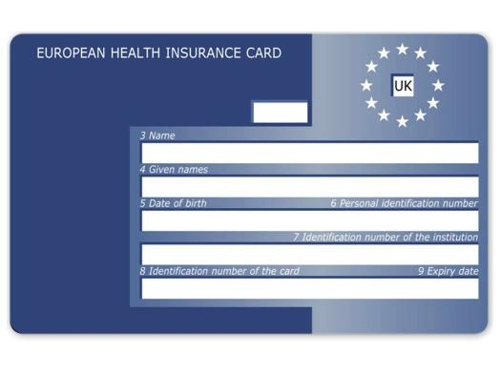 | Country Code:
 | 3: Name
 | 4: Given Names
 | 5: Date of Birth |  | DD MM YYYY
6: Personal Identification
Number
7: Identification number
of the institution
8: Identification number
of the card
 | 9: Expiry date |  | DD MM YYYY
PRC validity period (a) From: | DD MM YYYY |  | (b) To: | DD MM YYYY
Please tick if you have an S1 (eg. you are retiring to the UK or you have been posted here by your employer for work or you live in the UK but work in another EEA member state). Please give your S1 form to the practice staff.
How will your EHIC/PRC/S1 data be used? By using your EHIC or PRC for NHS treatment costs your EHIC or PRC data and GP appointment data will be shared with NHS secondary care (hospitals) and NHS Digital solely for the purposes of cost recovery. Your clinical data will not be shared in the cost recovery process.

Your EHIC, PRC or S1 information will be shared with The Department for Work and Pensions for the purpose of recovering your NHS costs from your home country.

Sample S1 Form

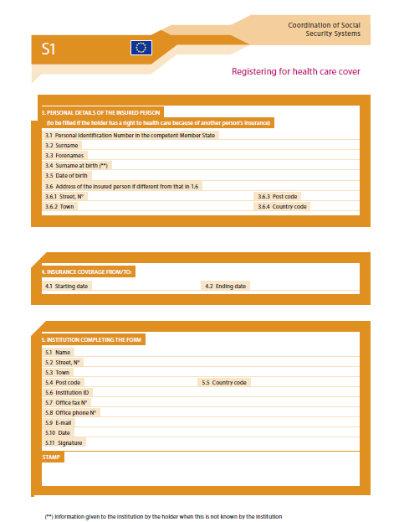

Issued to those who are resident in one EU country but work in another.

