2023/24 Reserve Funding Request Form

SECTION ONE: To be completed by the Provider. Please submit this form and any supporting information to your NHSE PH Programme manager for consideration.
This template is for non-recurrent reserve funding bids to support S7a Public Health services. Requests may be in relation to: Service Improvement, Increased Uptake, Inequalities, Other. All bids will be assessed by the PH COMMISSIONING & FINANCE LEADS with final approval by Commissioning Management Group and Public Health Commissioning Committee.

Provider / Request Information
Provider / Trust Name
ICB |  | Place (if applicable)
Person submitting application | Name  Job title  Email  Telephone
Date of request |  | NHS or Non-NHS Provider
Public Health S7a Programme
Funding Project Title:

Section 1 – Summary / Overview
Identify business need: (ie: Service capacity, improvement, expansion, increased uptake, addressing inequalities etc)

Project Aim:

Project Objectives/Deliverables:

Section 2 – Funding
Please detail the amount of funding applied for:
(Please include full cost detail of all pay & non pay costs requested. Please note that staff costs must be based on AfC mid-point (or equivalent) to include ERS NI & ERS Superannuation @ 14.3%). Costs to be provided on a full year basis and then pro-rated to actual months required. See example below.

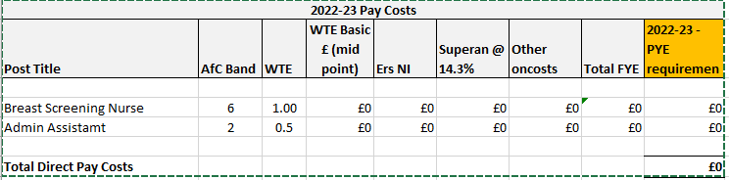
Please provide further details to support the funding request if needed.

Section 3 – Provider Investment (Financial / Non-Financial)
Reserve funding is available to provide additionality to existing commissioned services. Please provide details of where the business need has been raised internally, and justification for why the project cannot be funded within existing internal funding:

Please provide details of any funding / resource / equipment etc which the organisation will be contributing to match fund, support or enhance the NHSE funding requested:

Section 4 – Evaluation
Please provide details of evaluation methods. Monthly updates to be provided to NHSE and Final Report at completion of project or end of financial year 2023/24 whichever comes first.

Section 5 – Overall benefits / outcomes / value for money statement
Describe what the impact of the investment will be, how the investment will be measured, plus key milestones and targets. E.g.: Increase in Activity, Reduction in waiting lists, Quality, Patient experience etc.

Embed any supporting documents here:

SECTION TWO: FOR NHS ENGLAND COMPLETION
NHS England Screening and Immunisation Place Lead
NHS England PH Programme Manager
PHPM to identify which strategic priority this will help to deliver

(INTERNAL) regional Financial assessment:
Responses are required to the questions below from the regional finance lead (including n/a) Please consider the following points:
Responses here
TOTAL VALUE REQUESTED over life of scheme/ Investment
Current provider TOTAL contract value
Current contract value for the programme/service
Annual % Increase to contract value
Impact on Activity
Indicative cost per case if applicable
Are funds required recurrently / non-recurrently;
(N.B. further assessment and approval is required for any recurrent funding requests)
What are the phasing of costs over the next year
Has the value for money impact been assessed and what evidence is there of this?
If this is not an extension to a current contract, how will the services be commissioned/procured to ensure competition and compliance with SFI?
Will funding / Resource be found internally or requested from other sources?
FINANCE RECOMMENDATION:

PSIM Feedback (Y&H only)

Commissioning Lead Feedback

Date of CMG approval

