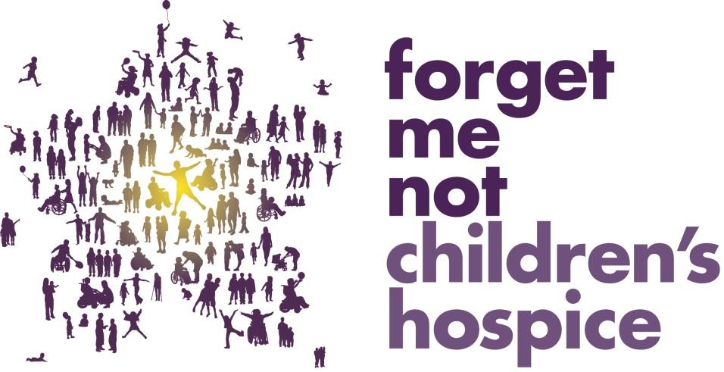

Trustee Information Pack

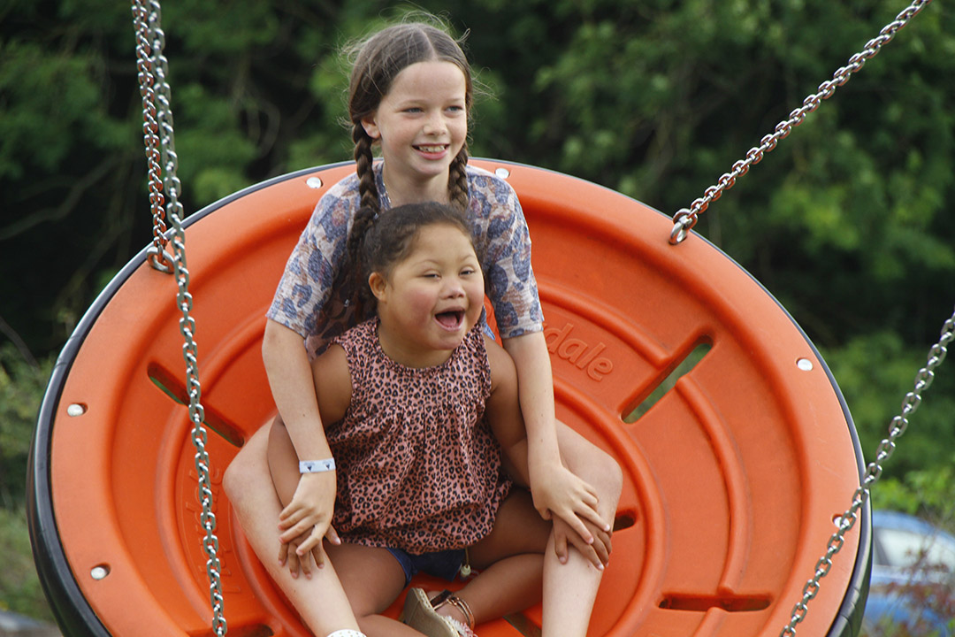

A MESSAGE FROM JEREMY CROSS, CHAIR OF THE TRUSTEES
Thank you for your interest in supporting Forget Me Not Children’s Hospice.

We have a reached a critical point in the development of our organisation and need to build a Trustee Board that can help guide our future as we consolidate our position and implement our new strategy in the post pandemic era.

We have experienced rapid growth in the last 10 years moving from an organisation that generated just over £500,000 a year employing less than a dozen people to one that employs over 130 people, with 350 volunteers, and needs to generate more than £5 million a year just to stand still. We have achieved a vast amount but this has really only allowed us to scratch the surface. There is so much more to do.

It’s an exciting organisation to work with and we are looking for Trustees who will add value to our existing skill set, bring lived experience and or can add to our diversity profile. It is important to us that our Board is truly reflective of the families we serve and so we would specifically welcome applications from people with diverse backgrounds.

Our Trustees are volunteers and as a volunteer you get the satisfaction and benefit of knowing you helped shaped significant support and improvement for many families, children and siblings living with life-shortening conditions, families who experience a child’s sudden death and families at perinatal stage who become aware that their pregnancy is very complex and may result in a stillbirth or neonatal death.

We began supporting children and families through our hospice at home service in 2011 and, soon after, opened the doors to our new purpose-built children’s hospice, Russell House, in Huddersfield. Last year, we celebrated 10 years of providing high quality services from our hospice to families right across West Yorkshire.

We have nearly 1000 families since opening our hospice, this includes families caring for a child with a life-shortening condition and bereaved families. But we have so much more to do. We know that in the areas we serve (Kirklees, Calderdale, Wakefield, Leeds and Bradford) there are more than 4,000 children living with life shortening conditions and the numbers are growing.

We are looking for Trustees who have the experience and skills to help provide strategic challenge and direction as we embark on this next exciting phase and look to the next 10 years.

I am incredibly proud of this organisation, the Senior Leadership Team and all the staff and volunteers who work exceptionally hard to deliver Forget Me Not’s vision: To deliver pioneering care and support through pregnancy, childhood and loss whenever families need us, whatever their future holds. As a Trustee, you too will become quickly engaged with our work and I’m certain become as inspired and as proud.

Jeremy Cross, Chair of Trustees on behalf of all of our Trustees

OUR STORY

Forget Me Not Children’s Hospice cares for children who have conditions which will significantly shorten their lives. Our children’s needs are complex and there are more than 400 conditions that we assist with managing to ensure that they live as full and happy lives as possible. Around 60% of the families that use our services come from ethnic minority communities, all have complex needs and their parents are carers and often siblings are young carers.

Our support can start in a perinatal clinic following a 16 week scan or on a neonatal ward, with a new mum who knows that she will give birth to a baby that may only live for just a few hours or days; through to caring for children who may live into their teenage years or even early twenties. However, all the children we care for have conditions which will severely shorten their lives.

For most of our children, our hospice is a second home; they love coming and the care team is an extension of their family. It’s a lively space where we provide a wide range of creative therapies for children and their brothers and sisters; planned respite to give mums and dads a break; sibling activities so brothers and sisters get some time and attention; crisis care to be there when families most need us; end of life care, bereavement care and many other forms of support. We are privileged to be able to help families make the most of every minute they have with their child, and to create some really special memories to hold onto long after their child has gone. We work hard to break down barriers to increase access to services, but there is more to do as numbers are growing, specifically in some communities that are particularly disadvantaged.

Beyond the hospice, a great deal of our care is provided in families’ own homes through our hospice at home service, which provides planned respite and other care on a weekly basis tailored to suit a family’s needs, and more recently, some of our support has been delivered online. We also provide in reach services to hospitals where our specific expertise is shared to support the child and their family when they need it most.

We do things differently
Many aspects of our service are unique even amongst children’s hospices. Here are just a few examples of how we do things differently:

- We are a nurse and therapy led service
- We use volunteers to help our care team support our families
- We work in partnership with local NHS trusts and provide support on wards
- We have developed a model that specifically supports perinatal and neonatal work and antenatal support
- We have developed a specialist sudden unexpected death in a child (SUDIC) service and work directly with West Yorkshire Police
- Our hospice at home service includes respite breaks as well as critical and end of life care
- We employ a South Asian support worker and an Eastern European support worker who both help to improve access to the hospice by breaking down known barriers in the communities we serve. We also have an Asian community engagement officer who helps to build wider links into targeted communities too.

What do we need to do next?
There are currently over 4000 children that need our support in West Yorkshire therefore, whilst we provide vital support to our current children and families, the demand for our services continues to grow and we will continue to reach out to these families. We have seen significant growth in our perinatal services, specifically in supporting the mental health needs of families who experience traumatic pregnancies and stillborn births. This work is very innovative and we would like to find ways in which we can help to replicate what we do in a broader arena.

We have taken the time to understand much more about the needs of our donors and are continually finding ways to engage them in our work. This year well over 90% of our funding will come from the local population and to ensure this comes in, we have to be able to open up the hospice and actively promote what we do whilst preserving the dignity and privacy of the families that we support.

We are also engaging much more within the local health and social care economy, securing funding by demonstrating our value and the cost savings offered to the NHS and local authorities, funding that will help to build our future sustainability. We have taken the lead in developing a collaboration of all the hospices operating in West Yorkshire and have now been able to position ourselves at the heart of the Integrated Care System where decisions are made about integration of services and flows of funding.

Finally, we continue to reshape and redefine our service models always ensuring that within limited resources we can provide care to the families who need it most and provide that within safe staffing models.

Why we do what we do

Thomas’s story

“Forget Me Not Children’s Hospice really is a lifeline to our family.”

After a difficult birth in 2014 and months of tests to try and find out what was wrong, Thomas was diagnosed with Congenital Central Hyperventilation Syndrome, an incurable condition. In and out of hospital, Thomas needed round-the-clock care. He had an operation on his stomach and a gastrostomy tube fitted. He has to have his ventilator with him at all times and must be watched all night and repositioned to help with his breathing.

It was after Thomas spent yet another period in hospital in 2015 that members of the Forget Me Not care team visited mum Leah and dad Jonathan to see how they could help.

Leah explains: “At this point we really needed help. I was a bit apprehensive when I heard the word ‘hospice’ and I didn’t know what to expect. But the first time that we went to Russell House we stayed for two nights in one of the family rooms and it felt like we’d had a two week holiday. The care team took all our worries away and made us feel so at home. Thomas even took his first steps during our stay.

Now nine, Thomas continues to come to Russell House for respite care – staying overnight and for occasional weekends to give mum and dad a break, sessions in our hydrotherapy pool, and joining in lots of play activities – he particularly loves books, trains, dinosaurs and dancing!

Leah says, “Thomas recognises the hospice as soon as we get into the car park and is literally banging on the door to get inside! The hydrotherapy’s great for his condition and we all get in the pool to spend some quality family time together. We feel safe knowing that everything Thomas needs is on hand and the care team are there if we need them.”

OUR EQUALITY, DIVERSITY AND INCLUSION PLEDGE

We believe in the development and embedding of an inclusive culture that respects people’s differences and gives everyone the best chance to excel at making a difference for the families we support.

In order to achieve this we pledge the following;

Our families
- We believe in equality of access to our services and including the voice of families in the ways in which services can be co-created, designed and delivered, both on a personal level and as a range of service offers.
- We will make sure our services and information are accessible to the community in which we operate.
- We will tackle barriers which might prevent some groups of people from accessing our services

Our people
- We will treat all of our employees, trustees and volunteers equally and fairly,
- We will embrace and celebrate our staff, trustees and volunteers’ differences, and create a positive working environment for all.
- We will reward our people equally for the same or equivalent work regardless of their age, race, religion or belief, sexuality, disability or gender.
- We will make sure that all our staff are trained in, and understand the importance of, equality and diversity and how this relates to the role they do.

Our recruitment practices
- We will actively encourage and support under-represented groups to join us as employees and to take up volunteering opportunities, including trusteeship
- We will always interview you If you are an applicant with a disability who meets the essential requirements of the job and will provide adjustments to the recruitment process if required.
- We are committed to supporting part time and flexible working; we will consider part time working requests for all our roles.
- We will advertise all roles with a single pay point so that you will know what your pay will be when you join us.

Our governance
- We will take steps to measure the diversity of the Board, senior leadership, staff, volunteers and service users by all relevant protected characteristics.
- We will identify what we can do to achieve fair representation from underrepresented groups at Board, senior leadership, staff, and volunteer levels. We will set targets and take action aimed at improvement.
OUR CURRENT TRUSTEES

Trustee biographies

Jeremy Cross (Chair)
Jeremy is a chartered accountant, but left the world of pure finance behind a long time ago to pursue a varied career in retail and then financial services. A few years back, for reasons of family/work-life balance, he gave up full time work to “go plural” with a number of paid and unpaid non-executive jobs. He is currently Chair of Mansfield Building Society and a non-executive director at Harrogate NHS Foundation Trust. In addition to his trustee role at Forget Me Not, he is also a governor at the grammar school at Leeds, together with roles at various smaller local charities.

Jo Ellis (Chair of HR & Governance committee)
Jo has 20 years’ experience in the NHS in a range of senior leadership roles, including being Director of Women and Children’s Services for 8 years. More recently Jo has been leading an emerging consultancy offer with Mace Strategic Advisory Services focusing on delivering improvements for people and the places they live. Jo is passionate about developing positive organisational culture and behaviours and helping everyone reach their potential. Jo is also a School Governor.

Sarah Ramsey
Sarah has +20 years’ experience of working in finance, strategy, business planning and transformational change. Sarah works at The Co-Op and leads the portfolio managing the transformational change programmes across the business. Sarah previously held numerous senior director positions at Asda and ran her own consulting business providing strategy & change director level services to retailers and consumer focussed businesses. Sarah is a qualified accountant having spent a significant amount of time at KPMG advising clients on M&A transactions.

Claire Woodford (Chair of Clinical Governance Committee)
Claire has 35 years’ experience in the NHS, starting as a general nurse and then training as a paediatric nurse in the early 1990’s at Royal Manchester Children’s Hospital where she worked on a neurology and metabolic ward before taking up a matron’s post for medical specialties. She is currently Deputy Chief Operating Officer at Stockport NHS Foundation Trust, a role that she moved into in August 2021 after 5 years as a Divisional Director of a Women and Children’s service. Claire maintains her paediatric nursing registration and stays close to children’s services both in hospital and community settings, most recently leading on integration between health and local authority child and family services in the local area which has been rated as Outstanding by the CQC. In her current role she sits on the Greater Manchester Children’s Health and Wellbeing Board and has a keen interest in reducing inequality and ensuring co-production is promoted with families, children and young people.

Adrian Gordon
Adrian has worked for nearly 20 years in the not-for-profit charitable sector, primarily in social housing for one of the largest registered providers in the country. For the last decade he has worked in governance and as a deputy company secretary. In 2019 he obtained associate status as a chartered company secretary/governance professional from ICSA/The Governance Institute.

David Anderson
David retired from General Practice in 2017 after 34 years working locally based in Fartown. He also was involved in local commissioning organisations PCG and PCTs between 2002 and 2011 and was then a non-executive director at Calderdale and Huddersfield Foundation Trust for seven years. His enthusiasm for developing local services remains and he hopes he can bring his experience of working with families in the heart of the local community to the hospice.

Tim McBurney (Chair of Audit, Finance and Risk committee)
Tim has worked for 15 years in the finance sector. During this period he has provided guidance and support to small and medium sized enterprises and corporate entities to help them successfully trade through challenging periods and to grow organically or through mergers and acquisitions. Following several transactional based roles earlier in his career, Tim now leads a team focused on capital and pricing with additional responsibility for portfolio level change projects.
Alex Clements
Alex is a solicitor with over 25 years of experience specialising in all aspects of employment law working with a variety of business and senior employees within the NHS. She has spent all of her working life in West Yorkshire and is currently a partner with Bexley Beaumont. She has worked with Forget Me Not over a number of years and is excited to be able to continue to support the hospice as a trustee.
Marge Falconer
With 35 years of experience working in the healthcare sector, Marge is an experienced hospital manager and has worked in both the NHS and the Independent sector. Having initially qualified as a nurse, she maintains a passion for patient-focused quality care. “The care and compassion I had when going into nursing will never leave me.” Having recently taken an early retirement, Marge now wants to give back and support the local community. She sees being a trustee at Forget Me Not as a privilege and hopes that her strong business acumen and passion for quality care will help support and guide the hospice on it’s exciting journey into the future.
Harvey Stead (Chair of Trading Board)
Harvey is a local business man and is the MD of the Redde Group of Companies which encompass Auxillis, FMG, New Law, FMG Repair Services (formerly Nationwide Crash Repair) and Principia. Each of these businesses is focused on providing bespoke claims management, legal and specialist accident management and vehicle repair services for the fleet and motor insurance sector.

Sofia Gohir
Sofia has 13 years’ experience working in the legal industry in the UK and Middle East. She works for Sport England as a senior in-house Solicitor providing legal advice, including business affairs, compliance and risks relating to the operations of the business. Sofia previously held the position of Legal Counsel for a technology company based in Dubai, advising on commercial affairs, supporting the Middle East and North Africa offices. Sofia started her career after qualifying as a solicitor of England & Wales, in private practices in London, at The Coca-Cola Company, working in legal operations and compliance on behalf of the Middle East Region and advising in intellectual property on behalf of the Eurasia & Africa Group.
Trading Board
In addition to trustees, we also have a trading board, the directors of which support our trading company, which is wholly owned by the charity. The trading board takes responsibility for our shops and online trading activity, which together provide over 40% of our income each year.

OPPORTUNITIES
The charity is looking to appoint further Trustees to the main board and within our Audit Finance and Risk Committee and Clinical Governance Committee. We would particularly welcome people with finance, accountancy or treasury skills, clinical, therapy or social work experience together with lived experience and or from a diverse background to support our equality, diversity and inclusion work.

Joining us as a Trustee
Trustees fulfil their roles on a voluntary basis. Our Trustees will normally be expected to serve for at least one term of three years, but will serve no more than two such terms.

The Board of Trustees is the governing body of Forget Me Not Children’s Hospice and is responsible for providing strategic direction with the Chief Executive and the Senior Leadership Team as well as providing oversight to ensure the charity operates properly and effectively. As an organisation it is vital that we have a diverse board that have a broad range of experience and skills at board level and represent the communities we serve. Over 60% of the families we work with come from ethnic minority communities and at the moment, our board is not fully representative of that. This is something we seek actively to change.

Trustees provide Forget Me Not Children’s Hospice with vital skills, expertise, experience and commitment essential to the effective management and future development of the charity. No one Trustee is expected to have all the skills; we seek a Board that as a whole has the right combination of skills, experience and knowledge. The Board acts collectively in its work.

Trustees have key responsibilities for the organisation. They are in law the guardians of its purpose and are expected to direct the strategy (working with staff); maintain financial oversight, assume responsibility for resources and are expected to ensure the organisation stays within the law.

Each Trustee must be able to:

- Devote the necessary time and effort, including both preparation and attendance of board meetings
- Attend any subcommittees of the board that require input relating to an individual’s specific area of expertise.
- Demonstrate strategic vision and be able to provide support, challenge and direction to the senior leadership team
- Understand and assess risks whilst ensuring a commercial approach
- Provide an independent and objective view
- Think creatively and continually look at ways of driving the charity forward in a commercial way
- Be willing to speak their mind and provide constructive challenge to other members of the board
- Understand and accept the legal duties, responsibilities and liabilities of trusteeship
- Be able to work effectively as a member of a team and to maintain good working relations.

Trustees are supported within the Committee structure by key members of staff who are assigned to committees based on their professional expertise and experiences. Our 3 committees include Audit, Finance & Risk (AFR), HR & Governance (HRG) and Clinical Governance (CG). Trustees will be expected to become a member of one of these committees. We also have a trading board and for good governance, one of our trustees also chairs the trading board.

Who can become a Trustee?
Over a million adults of all ages, social backgrounds and walks of life become Trustees of voluntary organisations. Some people are disqualified by law from acting as Charity Trustees, including anyone described in Section 72 (1) of the Charities Act 1993. Broadly that covers:

- Anyone who has been convicted of an offence including deception or dishonesty, unless the conviction is spent
- Anyone who is an undischarged bankrupt or is the subject of a bankruptcy restriction order or bankruptcy restriction undertaking
- Anyone who has made a composition or arrangement with or granted a trust deed for his or her creditors and has not been discharged in respect of it
- Anyone who has previously been removed from trusteeship of a charity by the court of the Charity Commissioners
- Anyone who is under a disqualification order under the Company Directors Disqualification Act 1986 or is the subject of a disqualification undertaking
- Any offer of appointment as a Trustee or Independent Advisor is also dependent on a satisfactory DBS check and references.

What commitment do I need to provide as a Trustee of Forget Me Not Children’s Hospice?

Trustees carry out their role and responsibilities by working closely with the other members of the Board, and the charity’s Senior Leadership Team. Involvement can vary from person to person but the minimum requirements are as follows:

- Regular attendance and contribution to Board meetings which are normally held six times a year (4 meetings and 2 awaydays)
- All meetings are currently held in Huddersfield, West Yorkshire. There has been an option to hold meetings virtually and in future a blended approach may be on offer for some meetings.
- Attendance and contribution at any subcommittees of the board that require input relating to an individual’s specific area of expertise. Sub committees meet no more than 4 times a year and are held virtually.
- Being available on occasion for specific task and finish groups or other activity such as recruitment, audit activity or networking for example
- Contributing to the annual appraisal of the CEO
- Providing support and mentorship as required to members of the Senior Leadership Team (SLT)
- Occasionally representing the charity at external events
- To act in as an ambassador of the charity by seeking out opportunities to generate support and facilitate the growth of the charity.

What are the liabilities of Trusteeship?
Trustees are ultimately responsible for everything the charity does and how it does it. They must ensure all activities and actions are within and accountable to the law.

Trustees have a duty to act in good faith. Trustees must avoid conflicts with any personal interests and should declare those that do arise. They may not profit from their role, although appropriate expenses can be reimbursed.

Instances of Trustees being found liable for the misconduct of charities are rare in the UK. However, it is important Trustees understand what their potential liabilities are. Trustees can be held personally liable for:

- Breach of trust – for example spending money inappropriately, or engaging in non-permitted political activity
- Breach of fiduciary and statutory duties – for example using assets to procure benefit for the trustees
- Fraudulent trading – incurring a debt knowing it cannot be repaid
- Acting as a company director when disqualified
- Failure to comply with statutory requirements, e.g. health and safety, HMRC, financial services.

The establishment of Forget Me Not Children’s Hospice Ltd as a company limited by guarantee protects Trustees’ liability to £10 each, provided they have acted in good faith.

More information about being a Trustee of a charity can be found in the Charity Commission for England and Wales’ publication “The Essential Trustee: what you need to know” or at:
The essential trustee: what you need to know, what you need to do (CC3) - GOV.UK (www.gov.uk)

I’m interested, what do I do now?

For a confidential conversation about the role, please call Luen Thompson, Chief Executive on 07808 789299. If you wish to apply, please send a CV and covering letter setting out how your skills and experience relate to the role you are applying for. We would also like you to complete a skills matrix. Please then email all the information to luen.thompson@forgetmenotchild.co.uk Interviews will be arranged on an individual basis as and when applications are received.

